Human computer Interaction (HCI)

The British College

**Student Name: Ayush Panta**

**Student ID: 77189984**

**Submitted Date: 22 March 2021**

Contents

Context 3

Evaluation of the Site 5

Evaluation Criteria 5

Evaluation Techniques 6

Evaluation Technique Used 6

Evaluation Technique Outline 6

Participants Profile 7

Heuristic Evaluation 7

Questionnaire 7

Findings of the tasks 7

Tasks to conduct 7

Post Questionnaire Findings 11

Heuristic Evaluation Findings 12

Critical Analysis of Data 14

Questionnaire Evaluation Technique 15

Heuristic Evaluation 17

Reflection and Further Work 18

References 19

Appendices 21

Participant Portfolio Form 21

Briefing Note 22

Consent Form 22

Tasks 24

Sample Questionnaire 24

Heuristic Questionnaire 24

Questionnaire 30

Lists of general HCI principles 41

# Context

In this report, I will be evaluating the websites <https://www.nike.com/> (Fig1) and <https://www.adidas.co.uk/> (Fig2). These are some of the biggest brand names who develop footwear and other clothing accessories for athletes. These websites have a huge audience cause these companies have global reach. Therefore since it will be used by people of different age groups and more importantly computer knowledge we can evaluate in a wide variety.

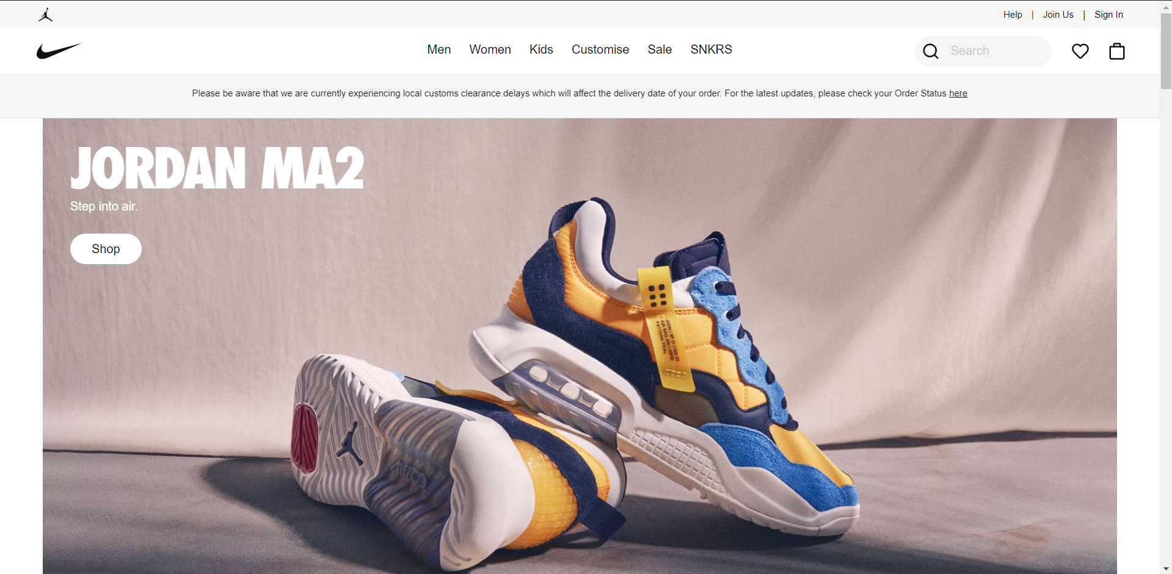

Figure 1 Home page of Nike

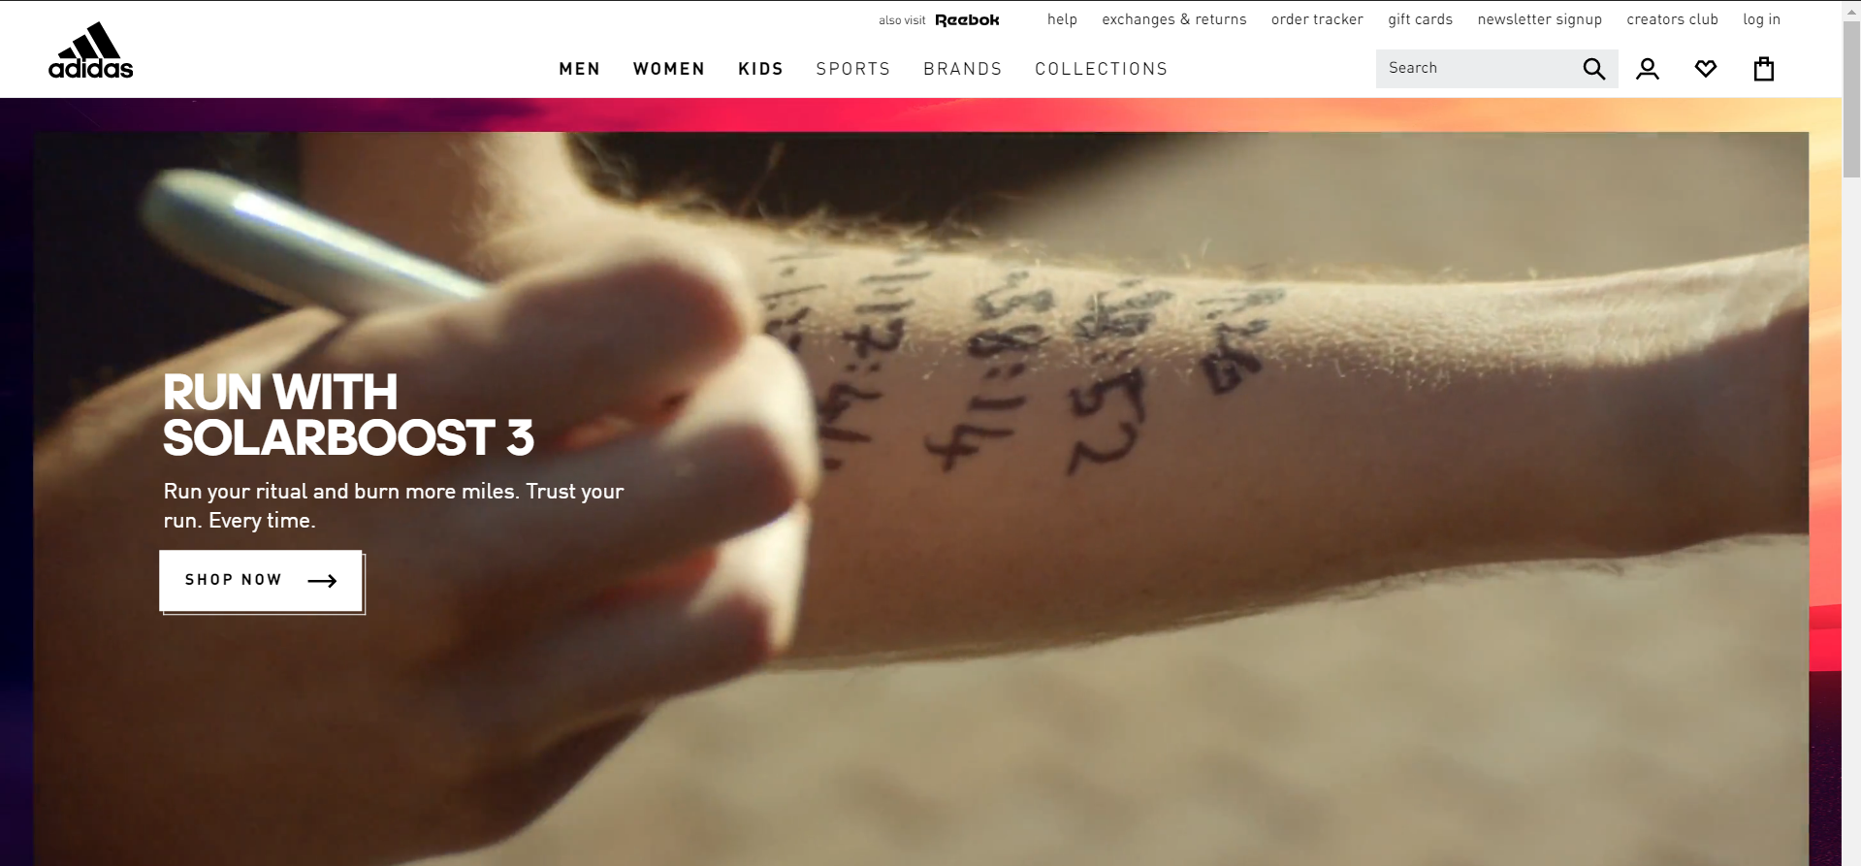

Figure 2 Home page of Adidas

I will be using Ben Shneiderman’s (2010) “Eight golden rules of interface design” and Jakob Nielson’s (1994) “Ten Usability Heuristics for User Interface Design” to evaluate the websites for the project. The principles focus on evaluating the usability of the website along with the user interface.

I will be dividing the report into three parts. Evaluation, Critical Analysis and Reflection.

Firstly, the participants will perform a set of tasks on the website. Then, the results we achieve will be critically analyzed. The participants will also be provided with a questionnaire with some heuristic questions. The generated data will be used to analyze the website on their usability, user interface and an overall use experience. Issues and recommendations will also be provided at the end.

This is how the report is set out to be performed.

# Evaluation of the Site

**Evaluation** is a process that critically examines a program. It involves collecting and analyzing information about a program's activities, characteristics, and outcomes. Its purpose is to make judgments about a program, to improve its effectiveness, and/or to inform programming decisions (Patton, 1987). It is a process to test and judge whether they can meet the user requirements staying within the principles of Human Computer Interaction (HCI).

## Evaluation Criteria

Evaluation criteria are the standards that are set to judge the website for their overall user experience and usability.

|  |  |
| --- | --- |
| Criteria | Description |
| Navigation | Navigation is one of the most important factors when it comes to a website. It is more likely that a person will intend to discover the website if it has proper navigations. Navigations allow the user to know where they are and where other they can proceed. |
| Efficiency | In this competitive world, just a matter of seconds can make all the difference. Therefore, the website should not be very heavy in terms of loading speed. No one will have the urge to sit around and wait for a site to load. They will simply move on to something that’s more faster and efficient. So, efficiency does play a huge role on the evaluation. |
| Simplicity | Being simple can make a huge difference. Since, not all people who use the site will have equal computer knowledge. The site will be used by all sorts of people with different understanding of computers. So the more simpler the website, the more customers it can target and the more attention it will grab. So being simple is a key to target a large number of customers. |
| Consistency | Being consistent can make a considerable amount of impact on a customer’s mind. Consistency plays an important role by helping users become familiar with the digital landscape of your product so they can achieve their goals more easily (Shneiderman, 2010). Having to learn a new pattern or approach every time you proceed to a new page can be stressing for some peoples and will decrease the overall user experience of the website. |

Evaluation Techniques:

There are certain method or techniques to evaluate the system against the criteria mentioned above.

The reasons to evaluate a system:

* To get the overall user experience of the system.
* To maximize the system usability
* To identify the errors or user interface issues

### Evaluation Technique Used

Heuristic evaluation and questionnaire are the chosen methods for this report.

#### Heuristic evaluation

Heuristic evaluation is a process where experts use rules of thumb to measure the usability of user interfaces in independent walkthroughs and report issues. Evaluators use established heuristics and reveal insights that can help design teams enhance product usability from early in development. It was founded by Jakob Neilson in 1995. A questionnaire has been used to determine the standard of the website among all the techniques inside the heuristic approach. The opinions of all the participants were gathered as we asked open questions to measure the usability of the websites.

#### Questionnaire

A questionnaire is a research instrument that consists of a set of questions or other types of prompts that aims to collect information from a respondent. Using some specific task based questions we can gain accurate answers to use for evaluation. Designing a poor questionnaire can be very backfiring as they wont be much useful for evaluation. However, since the questions are task based the results can get very impactful for the report.

## Evaluation Technique Outline

For the evaluation, five participants with different knowledge on the field of computer were brought to the subject. They were given specific tasks to perform on the website which will uncover the overall usability of the site.

The results will be challenged with the evaluation criteria which was prepared beforehand.

The analysis will be done on the basis of how the participant has given the answer and since they have more freedom on what to write we will have easier understanding on how the customer feels for the overall user experience and usability.

### Participants Profile

All the participants are above 18 and not related to the HCI field.

|  |  |  |
| --- | --- | --- |
| Participant | Technical Scale | Field of study |
| Participant 1 | Low | shopkeeper- uses computer for CCTV footage or playing card games |
| Participant 2 | Low-mid | teacher – uses computer for preparing question sheet |
| Participant 3 | Low-mid | restauranter – uses computer for adding and removing offers |
| Participant 4 | Mid-High | student – uses computer for doing college projects |
| Participant 5 | High | developer– uses computer for their work |

### Heuristic Evaluation

The questionnaire technique (Appendix) in heuristic evaluation is used to evaluate in this method. Here, the users will answer the open-ended question and based on their answer, the site will be evaluated against the heuristic evaluation principles.

Since the answers gotten from the user is their opinions and vary from each individual, the finding is qualitative. The finding from this technique will be presented in a tabular format and then be compared with the heuristic principles.

### Questionnaire

Here, as shown in the appendix, the participants were asked their opinions on the website. The result gotten from this survey will help to find out whether the sites actually follow the HCI principles. The findings gotten from this evaluation technique will be then critically analyzed against the Neilson (1995) and Shneiderman (2010). The result from this method will be presented in a visual form with the help of charts.

## Findings of the tasks

### Tasks to conduct

All the data and questionnaire can be found in the appendix given at the bottom of the page.

|  |
| --- |
| **Tasks** |
| Open any link in the navigation/menu |
| Search for any product in the search bar |
| Find the register button |
| Find the button to switch the language |
| Find the button to sign up for the newsletter |

Now the tasks have been assigned, the participants will conduct their work.

#### Task 1

Figure 3: Participants performing task 1

#### Task 2

Figure 4: Participants performing task 2

#### Task 3

Figure 5:Participants performing task 3

#### Task 4

Figure 6: Participants performing task 4

#### Task 5

Figure 7: Participants performing task 5

### Post Questionnaire Findings

The findings to why the participants chose what they chose in shown below. You can see the questionnaire with actions performed in tasks in the appendix below.

Figure 8: The figure showing why navigating through the pages was difficult

Figure 9 Figure showing how easy was it to navigate Adidas in mobile view

Figure Figure showing how easy was it to navigate Nike in mobile view

### Heuristic Evaluation Findings

After evaluating the sites again heuristic evaluation principles, following findings were found.

|  |  |
| --- | --- |
| Principle | Findings |
| Consistency and Standards | Both Nike and Adidas do maintain consistency throughout their websites. The layout if each page is consistent with similar font style, size, color, layout design making the user easy to familiarize with the website |
| Help and Documentation | Help page is important for users to get back in track if they lose their way within the website. In both sites, Nike and Adidas, help page link provided in the navigation at the very top of the page, but it could be a little more helpful if it were bigger in font size and darker in color |
| **Recognition rather than recall** | Best way to impress user is to show them they don’t have to put effort in navigating throughout the website. In both Adidas and Nike, the search functionality gives the user options to choose from without having the users type in the whole world. It both saves time of users and they don’t have to recall what they want every single time they visit the site |
| **Flexibility and Efficiency of use** | **A website can be visited by many people, majority of whom do not have any kind of computer skills whatsoever. Therefore, it is necessary for the website to be built in a way that is flexible and efficient enough to be used by any kind of user easily. Here, the registration process of Nike is quite easy, but the registration process of the Adidas is a bit tricky and it can confuse the users without any computer knowledge.** |
| **Aesthetic and minimalist design** | **Since both the websites are globally acclaimed companies, there are bound to be many important things to show in the website. However, this should be done keeping in mind of this particular principle. Both Adidas and Nike have multiple pages and it might look a little cluttered in the navigation. Nike does not function properly and many of it’s features are cut off in the responsive design but Adidas is well adjusted according to the criteria of responsiveness of a website** |

**.**

# Critical Analysis of Data

Firstly, based on the evaluation techniques used, the problems in the user interface and the usability of the website, along with the recommended solutions are provided below.

|  |  |
| --- | --- |
| **Findings** | **Recommendation/ Solutions** |
| **Navigation**- Based on the tasks performed by the participants, the navigation of the site is confusing. The visited pages do not show the link or change in color, which makes it difficult for user to know where they are, which breaches the principle of Dix et Al(2004) who suggests, “You need to know what is going to happen when a button is pressed, to understand where you are in the interaction” | The site should be designed in a way that shows a change in color, or any kind of change to the link that show the page is already visited or the user is currently in that particular page. |
| **Efficiency** – Being globally acclaimed companies they are bound to have huge amount of information to be displayed. This reduces the efficiency of the website. From the evaluation of the tasks from participants, it is concluded that Nike has more loading time than Adidas websites. Navigating the pages Nike website takes longer than that of Adidas | Nike should work on increasing the efficiency of their website. Compressed Images, reducing excess information, minimizing the number of files, contacting with the host service would be the recommended solutions to these. |
| **Simplicity**- Based on the findings of both Heuristic Evaluation and the tasks performed, the sites are found leaning towards people with more computer skills. The functions of finding a desired product, adding them, buying them was a problem faced by people of non-IT backgrounds. | The sites should work in making the functionality a bit simpler. Providing help modals in these pages, not cluttering excess information at the same page, keeping the information where the user expects them to be would make things easier for them. In Adidas, there is no sign-up button. A simple sign-up button at the top of the page would make things a lot easier. |
| **Consistency**- According to the findings from both evaluation techniques, the layouts through-out the page are quite well maintained; however, the responsive view of Nike is not up to the standard. Features are being cut off, there is no clean design in mobile view. | The company should work on making the site responsive. In today’s world where most people operate from their mobile, it is very important that a big brand like Nike has the standardized mobile view design of the system. |

### Questionnaire Evaluation Technique

#### Task 1

**Analysis**

**Task1 was to navigate through the websites. As the chart shows, participants needed more time to navigate through Nike then Adidas and there might be multiple factors affecting the results. In the chart showing why the navigating process was faster in Adidas, many factors like Page loading time, Image Loading time, not keeping able to track what’s happening plays role.**

**HCI Principle**

Shneiderman (2005) has stated in his eight golden rules for better interface design that informative feedback is essential. In the website, the users find it hard to track down what page they are visiting as there is not any feedback given to the user such as navigation menu highlighted or change in colour. Also, according to Dix et Al (2004), “You need to know what is going to happen when a button is pressed, to understand where you are in the interaction”. This website does not follow these principles in their navigation menu.

#### Task 2

**Analysis**

**Task 2 was to search any product in the search Bar. As the record shows, the searching process took longer time in Nike than in Adidas. The auto suggestions popped out seconds later after tying the product in Nike than in Adidas. In Adidas the process was faster than in Nike.**

**HCI Principle**

**Heuristic Principles of Neilson (1994) suggests that the system should let users recognize their actions or options rather than remembering it. The search option in both of this website is supported by auto suggestion. The users don’t have to remember to write entire word. They can just give few letters in the bar and the search auto suggests what the user might be interested in. The Heuristic principle says that the user must be able to get the information they need easily without forcing them to rely on their memory.**

#### Task 3

**Analysis**

**Task 3 was to find the register button in the page. Adidas had a confusing process for user to find out where the register button ins unlike Nike where it was placed right at the top beside the Log in button. In Adidas, the user has to click on log in and then find the option to register which can be a bit difficult and confusing process for people with less computer skills.**

**HCI Principle**

**According to the Neilson (1994), the system should be flexible enough for the users to find what they need easily and fast. The register button on Adidas was hidden in multiple clicks which might confuse and distract the less experienced users. The websites should be build keeping in mind that many kinds of users use the system. Ranging from non-technical people to people with high computer skills. The website does not match the standard of HCI principle if the system seems flexible for only technical people.**

#### Task 4

**Analysis**

**Task 4 was to switch the language once you are in the website. Both websites being global companies, give users the option to chose their desired language. In Adidas, the user had to search a while to find the option to switch and then ever more confusing process to actually switch. But in Nike, even though it took some time for user to find the button, they could easily select the language mode once the button was clicked.**

**HCI Principle**

**Once again, the system should be flexible enough for people of all skills to navigate throughout the website within reasonable time. The option to switch the language within the websites was difficult for the participants. Even though the task was confusing in both websites, Nike had easier way to change it than in Adidas.**

#### Task 5

**Analysis**

**Task 5 was to find the button which lets user to sign up for newsletter. The button was easily viewable, being placed at the very top beside the help button in Nike and users took fairly less amount of time to find it than in Adidas. In adidas, the user had to search and assume where the button might be and it might take users several clicks to actually find the button Thus, taking longer time to find out.**

**HCI Principle**

**One of the principles of Heuristic evaluation is to keep the design simple and not to clutter more information than needed. The task to find the button to sign up for newsletter was fairly easy in Adidas as it clearly mentions at the top. But in Nike, the user has to guess and navigate their way through cluttered information they don’t need to simply find a button to sign up for the newsletter. This principle of Heuristic evaluation clearly clashes with Nike and agrees with Adidas.**

### Heuristic Evaluation

In the Heuristic Evaluation of the site, a questionnaire was distributed to the participants. Based on the criteria on which the website was evaluated, the following principles of Heuristic Evaluation (1994) is discussed below

* **Consistency and Standards**

Participants were asked on which website had the most consistent layouts. 3 among 5 chose Adidas while the other 2 chose Nike. In this Heuristic evaluation, it all comes to the opinion of people. Some might find the fonts, colors and Designs of Adidas more than Nike and vice versa.

However, both websites follow the principle of Neilson (1994) to keep the site consistent and standard up to the principles of HCI

* **Help and Documentation**

The participants were asked If they had to visit the help page at any point while browsing through the website. 2 out of 5 participants answered no while others answered yes. They were also asked if they found out the answer to the question they were looking for. All the participants who answered they needed help chose yes.

Neilson (1994) says that having a clean and well documented help page is essential to solve user’s problem. Both Adidas and Nike follow this principle as the participants solved their confusion with the help of their well-documented help page.

* **Recognition rather than recall**

**The participants were asked which website was easier to find or search for products. 3 out of 5 answered Adidas while the other 2 chose Nike. On asking why, the participants answered that the auto suggestion in Nike search bar was bit late than in Adidas.**

**The recognition rather than recall principle tells that the user should not have to rely on their memory to find out what they need. Here the auto suggestion of the websites helps users do exactly that. On writing the first few letters, the sites suggest the possible solution to the users. The better efficiency of Adidas makes the users pick it as the better option out of the two.**

* **Flexibility and Efficiency of use**

**The participants were asked which website was easier to use. 3 out of 5 answered Adidas while the 2 other answered Nike. Even though some of the tasks were difficult and confusing to both the users, some users found one easier than the other.**

* **Aesthetic and minimalist design**

The participants were asked on which website they preferred the most in terms of visual and appearance. 4 out of 5 answered Adidas while one participant chose Nike.

Heuristic principle suggests the websites to have aesthetic but simple design without clutter of information. However, the answer to this question is solely based on people’s preference but among the 5 participants, Adidas came out as the winner.

# Reflection and Further Work

Evaluation process of both the site was lot smoother than I had expected. Among the 2 evaluation techniques, the heuristic approach made the results even more understandable than that of quantitative result of questionnaire.

The tasks set up for users to perform covered the principles of HCI and the criteria against which the sites were compared let me peek into the websites and learn how the globally acclaimed, worldwide big companies also cannot be perfect and have some fallback. However, nearing the completion of the evaluation, there were couple of things I could’ve done better to make the process even easier.

Upon making the questions and getting results from it, evaluating, discussing it and analyzing it, I have come to conclusion that the evaluation process of both the websites would have gone a lot more smoother had the questions were set to be of wide variety. The tasks the participants were asked to do could also have been better. While good results and findings were concluded from questioning 5 participants, even better and more understandable result would have been produced had the number of participants been lager. The set of tasks I prepared did not cover the issue of how disabled people would approach the website. Had I had prepared for it; the result would have been even more inclusive and fair.

These big companies could be even more inclusive if they made the website for range of people. As per the result of my finding, the people from non-technical background and the ones who do not have computer skills struggled more than that of technical background. The non-technical people found it hard to follow the actions of task and they had to search for things for relatively longer than that with technical people. Also, the navigation of both of these sites could be even better if they somehow let user understand where they are. Right now, the users have to scroll down to see where they are, which definitely goes against the HCI principle. Also, from the results, the users found the efficiency of Nike much slower than of Adidas. While it also depends on the user’s internet connection, it won’t hurt the site to make their site even more efficient.

The sites would be even more useful to the users taking these recommendations in accounts and evaluating my own shortcomings during the evaluation, the portfolio would have had more impact had I had a detailed and planned process.

**(Word Count: 4000)**

# References

* Benyon, D (2010) *Designing Interactive Systems,* 2nd ed, Harlow: Pearson. E-book: <<http://ezproxy.leedsbeckett.ac.uk/login?url=http://www.dawsonera.com/depp/reader/protected/external/AbstractView/S9780273743538>**>** [Accessed 18 March 2021]
* Dam, R and Siang, T (2018) *Design Thinking: New Innovative Thinking for New Problems* [Internet], Available from: <<https://www.interaction-design.org/literature/article/design-thinking-new-innovative-thinking-for-new-problems>> [Accessed 18 March 2021]]
* Dix et al (2004) *Human Computer Interaction*, 3rd ed, London: Prentice Hall. E-book: <https://www.researchgate.net/publication/244486422_Human-computer_interaction> [Accessed 18 March 2021]
* Gray, W. D., & Salzman, M. C. (1998). Damaged merchandise? A review of experiments that compare usability evaluation methods. Human–Computer Interaction,13,203–262.[Online],Available from <[https://www.nngroup.com/articles/ten-usability-heuristics/](https://www.interaction-design.org/)>[Accessed 18 March 2021]
* Interaction Design Foundation (2020) *Interaction Design Foundation* [Internet], Available from: < <https://www.interaction-design.org/>> [Accessed 18 March 2021]
* Matera M., Rizzo F., Carughi G.T. (2006) Web Usability: Principles and Evaluation Methods: In: Mendes E., Mosley N. (eds) Web Engineering. Springer, Berlin, Heidelberg.[Online] Available from <<https://link.springer.com/chapter/10.1007/3-540-28218-1_5>>[Accessed 18 March 2021]
* Meister, D., Andre, T. S., & Aretz, A. J. (1997). System analysis. In T. S. Andre & A. W. Schopper

(Eds.), Human factors engineering in system design (pp. 21–55). Dayton, OH: Crew System Ergonomics Information Analysis Center .[Online], Available from <[https://www.nngroup.com/articles/ten-usability-heuristics/](https://www.interaction-design.org/)>[Accessed 18 March 2021]

* Molich, R., and Nielsen, J. (1990). Improving a human-computer dialogue, Communications of the ACM 33, 3 (March), 338-348. [Online], Available from <[https://www.nngroup.com/articles/ten-usability-heuristics/](https://www.interaction-design.org/)>[Accessed 18 March 2021]
* Nielson, J (1994) 10 Usability Heuristics for User Interface Design [Internet], Available from: < <https://www.nngroup.com/articles/ten-usability-heuristics/>> [Accessed 18 March 2021]
* Nielsen, J., and Molich, R. (1990). Heuristic evaluation of user interfaces, Proc. ACM CHI'90 Conf. (Seattle, WA, 1-5 April), 249-256. [Online], Available from <[https://www.nngroup.com/articles/ten-usability-heuristics/](https://www.interaction-design.org/)>[Accessed 18 March 2021]
* Northcott, D (2012) *The Difference Between Information Architecture and UX Design* [Internet], Available from: <http://www.uxbooth.com/articles/the-difference-between-ia-and-ux-design**/**> [Accessed 18 March 2021]
* Smith, M (2020) Shneiderman’s Eight Golden Rules Will Help you Design [Internet], Available from: <<https://www.interaction-design.org/literature/article/shneiderman-s-eight-golden-rules-will-help-you-design-better-interfaces>> [Accessed 18 March 2021]
* Wong, E (2018) *Heuristic Evaluation: How to Conduct a Heuristic Evaluation* [Internet], Available from: <<https://www.interaction-design.org/literature/article/heuristic-evaluation-how-to-conduct-a-heuristic-evaluation>> [Accessed 18 March 2021]

# Appendices

## Participant Portfolio Form

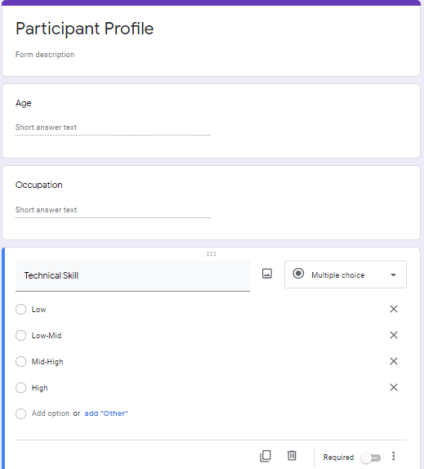

## Briefing Note

This document will explain the actions going on in the study. Please note that, you can withdraw from the survey anytime you want and there is no pressure for you to completely fill out the form. You must sign a consent form, but your personal details will be kept anonymous.

The purpose of this study is to find out the effectiveness of the websites and compare it to standard principles of the study. You are helping an education centre to research the experience of a user while navigating through a system.

You will be given two questionnaires, one filled with task and one where you can freely say your opinion about the system you visited. All the data from the questionnaires will be used to generate both qualitative and quantitative results which will allow us to dive deeper into this field of study.

If you have any other questions, do not hesitate to ask before signing the consent form.

## Consent Form

**EXPLANATORY STATEMENT**

**Usability and User Experience evaluation for Leeds Beckett University Level 6 Human Computer Interaction Assignment**

**Principal Investigator: Kritika Koirala**

**THE PURPOSE OF THE STUDY**

This usability study aims to evaluate the targeted websites. Thank you for volunteering to participate in the exercise, by doing so you are helping the University to better meet the needs of the students and its employees. This exercise is an important element in a program of research into the usability of the web.

**THE STUDY**

Firstly, I would like you to complete a:

1. An Informed Consent forms
2. User Profile (age, technical skill, occupation)
3. **Task-based experiment**:to explore the website looking for certain information required to complete the task. The testing equipment to be used are:
4. **Usability Questionnaire:** After the tasks have been completed you will be asked to complete a questionnaire asking for the feedback on the tasks you performed and your opinion on either of the website.

**Any Questions?**

I believe that there is effectively no risk involved in the participation in the proposed research. All participation in the research is entirely voluntary and can be stopped at any time. At the end of each session participants will have the opportunity to comment on the way the research was conducted. Data will be held for research analysis by Leeds Beckett University. All personal data will be treated confidentially, and no one will be identified in published material.

**INFORMED CONSENT FORM**

I agree that by signing the attendance schedule I am agreeing to take part in the above Leeds Beckett University evaluation project.  I have read the **Explanatory Statement**. To take part means that I am willing to:

* To provide my profile
* To perform the task
* To fill out the questionnaire

**Data Protection**

I understand that any information I provide is confidential, and that no information that could lead to the identification of any individual will be disclosed in any reports on the project, or to any other party. No identifiable personal data will be published.

**Withdrawal from being a participant in the study**

I understand that my involvement as a participant is voluntary, that I can choose to withdraw my consent to be a participant in the evaluation part of the assignment without being penalised or disadvantaged in any way.

| **Date** | **Time** | **Full name** | **Signature** |
| --- | --- | --- | --- |
| 3/16/2021 | 12:00 | Participant 1 | Participant 1 |
| 3/16/2021 | 12:30 | Participant 2 | Participant 2 |
| 3/16/2021 | 1:00 | Participant 3 | Participant 2 |
| 3/16/2021 | 1:30 | Participant 4 | Participant 4 |
| 3/16/2021 | 2:00 | Participant 5 | Participant 5 |

## Tasks

Tasks set for the participants to do

* Open any link or item in the menu
* Search for any desired products in the search bar
* Find the register button
* Find the button to switch the language
* Find the button to sign up for the newsletter

## Sample Questionnaire

### Heuristic Questionnaire

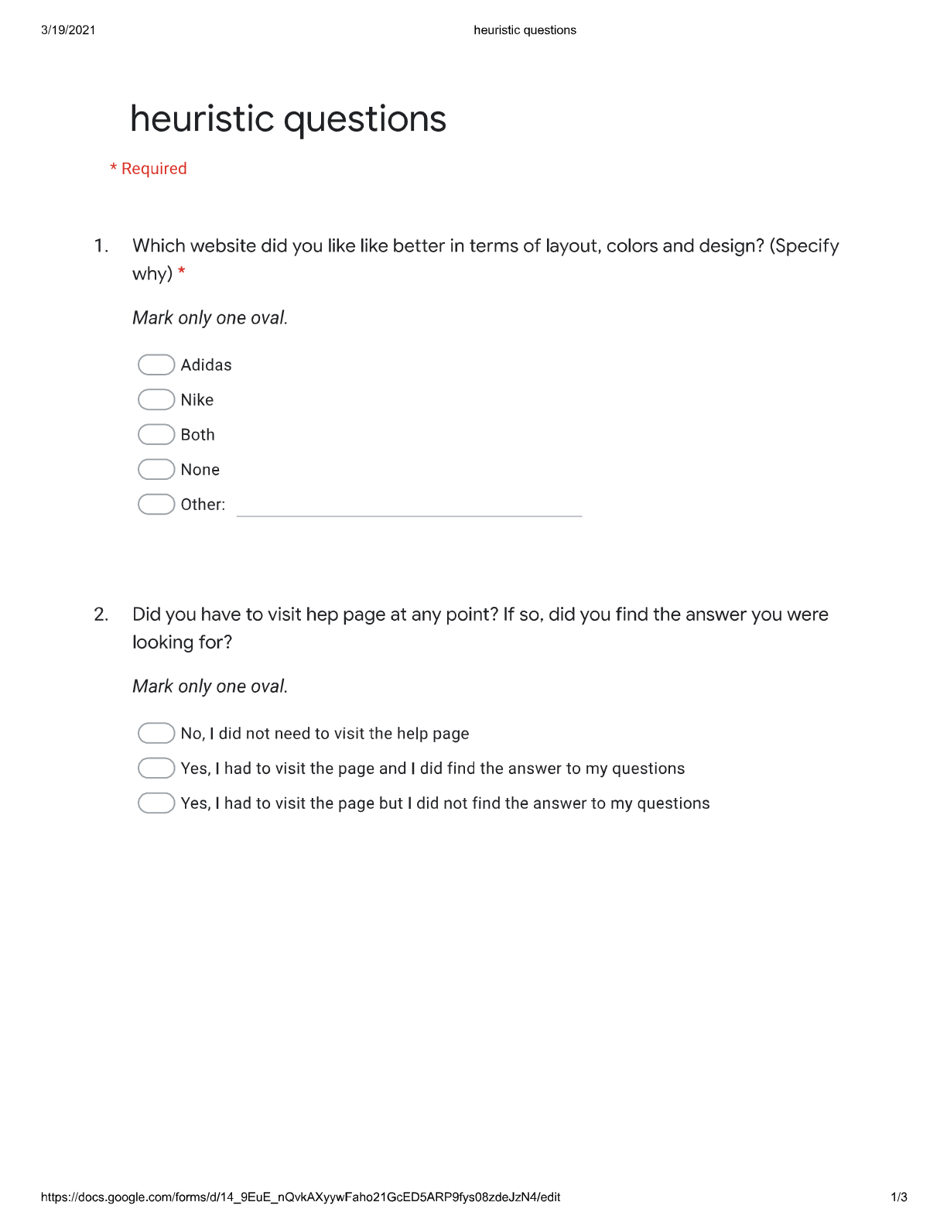

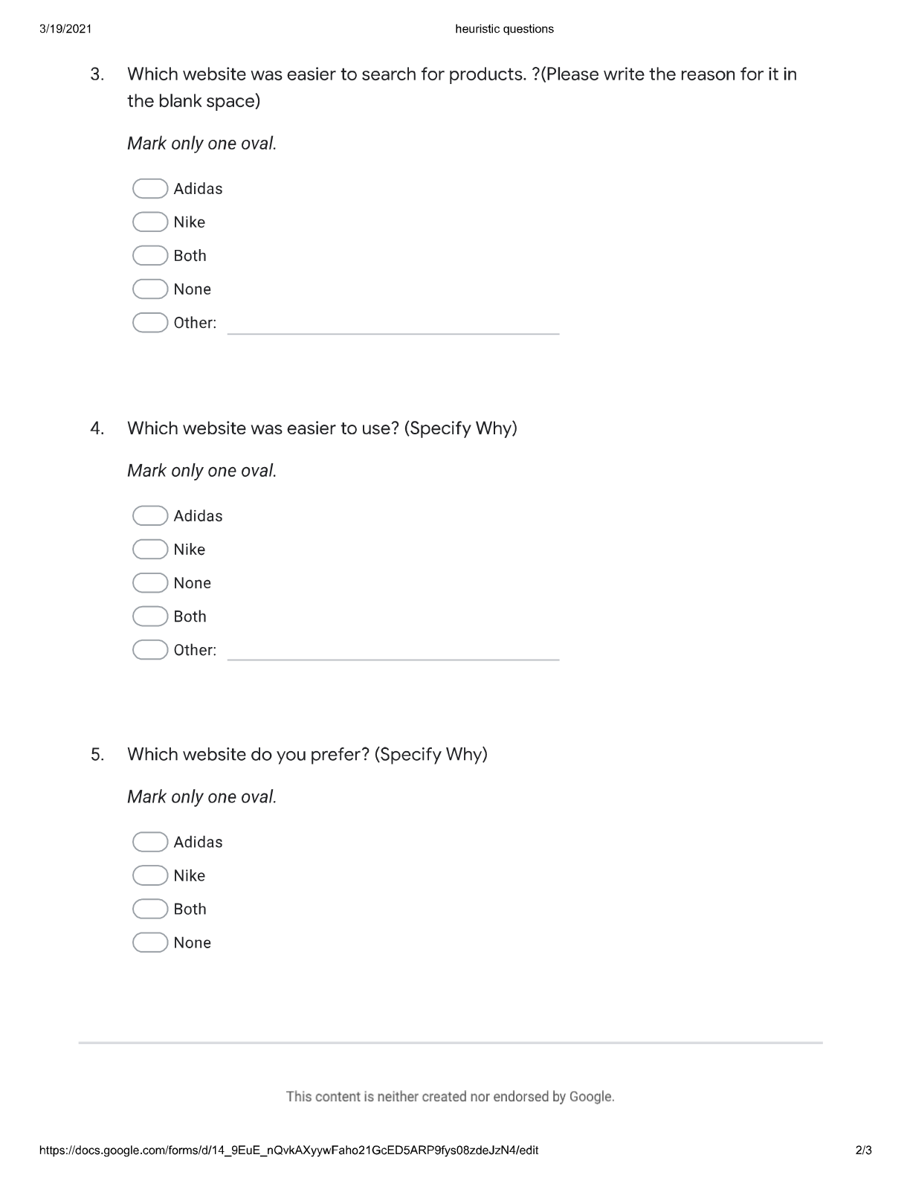



**Participant 1 Answer**

* Which website did you like better in terms of layout, colors and design?

Adidas because it has simpler layout compared to Nike and it was consistent through out the site.

* Did you have to visit hep page at any point? If so, did you find the answer you were looking for?

Yes, I did visit the help page to find out information about the product.

* Which website was easier to search for products? (Please write the reason for it in the blank space)

Adidas, mostly because it gave me suggestions faster than Nike

* Which website was easier to use?

Both were difficult but comparatively Adidas was easier.

* Which website do you prefer?

Adidas

**Participant 2 Answer**

* Which website did you like better in terms of layout, colors and design?

Adidas. I liked its design better than Nike

* Did you have to visit hep page at any point? If so, did you find the answer you were looking for?

Yes, I did visit the help page to find out how to find the products of my size.

* Which website was easier to search for products? (Please write the reason for it in the blank space)

Adidas, because the suggestions it gave me were helpful than that of Nike

* Which website was easier to use?

Adidas

* Which website do you prefer?

Adidas

**Participant 3 Answer**

* Which website did you like better in terms of layout, colors and design?

Adidas because I like the images of Adidas more than Nike

* Did you have to visit hep page at any point? If so, did you find the answer you were looking for?

Yes, I did visit the help page to find out how to sign up for newsletter.

* Which website was easier to search for products? (Please write the reason for it in the blank space)

Nike, because I found the suggestion of Nike more useful than Adidas

* Which website was easier to use?

Both were difficult but comparatively Adidas was easier.

* Which website do you prefer?

Adidas

**Participant 4 Answer**

* Which website did you like better in terms of layout, colors and design?

Nike, I like the design and I like the way they show their products better than Adidas

* Did you have to visit hep page at any point? If so, did you find the answer you were looking for?

No, I did not need to visit the help page

* Which website was easier to search for products? (Please write the reason for it in the blank space)

Nike, because it was faster, and it gave me more suggestions than Adidas

* Which website was easier to use?

Both were difficult but comparatively Nike was easier.

* Which website do you prefer?

Nike

**Participant 5 Answer**

* Which website did you like better in terms of layout, colors and design?

Nike. I like the icons and the design of it better

* Did you have to visit hep page at any point? If so, did you find the answer you were looking for?

No.

* Which website was easier to search for products? (Please write the reason for it in the blank space)

Adidas. I like the way they displayed all the options and information of the product when you search for it.

* Which website was easier to use?

Nike

* Which website do you prefer?

Nike

### Questionnaire

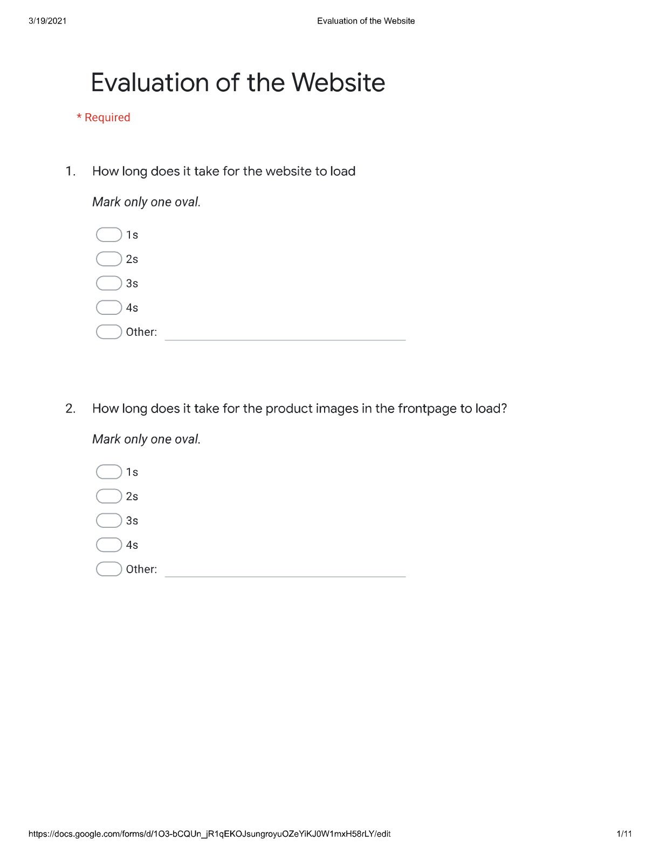

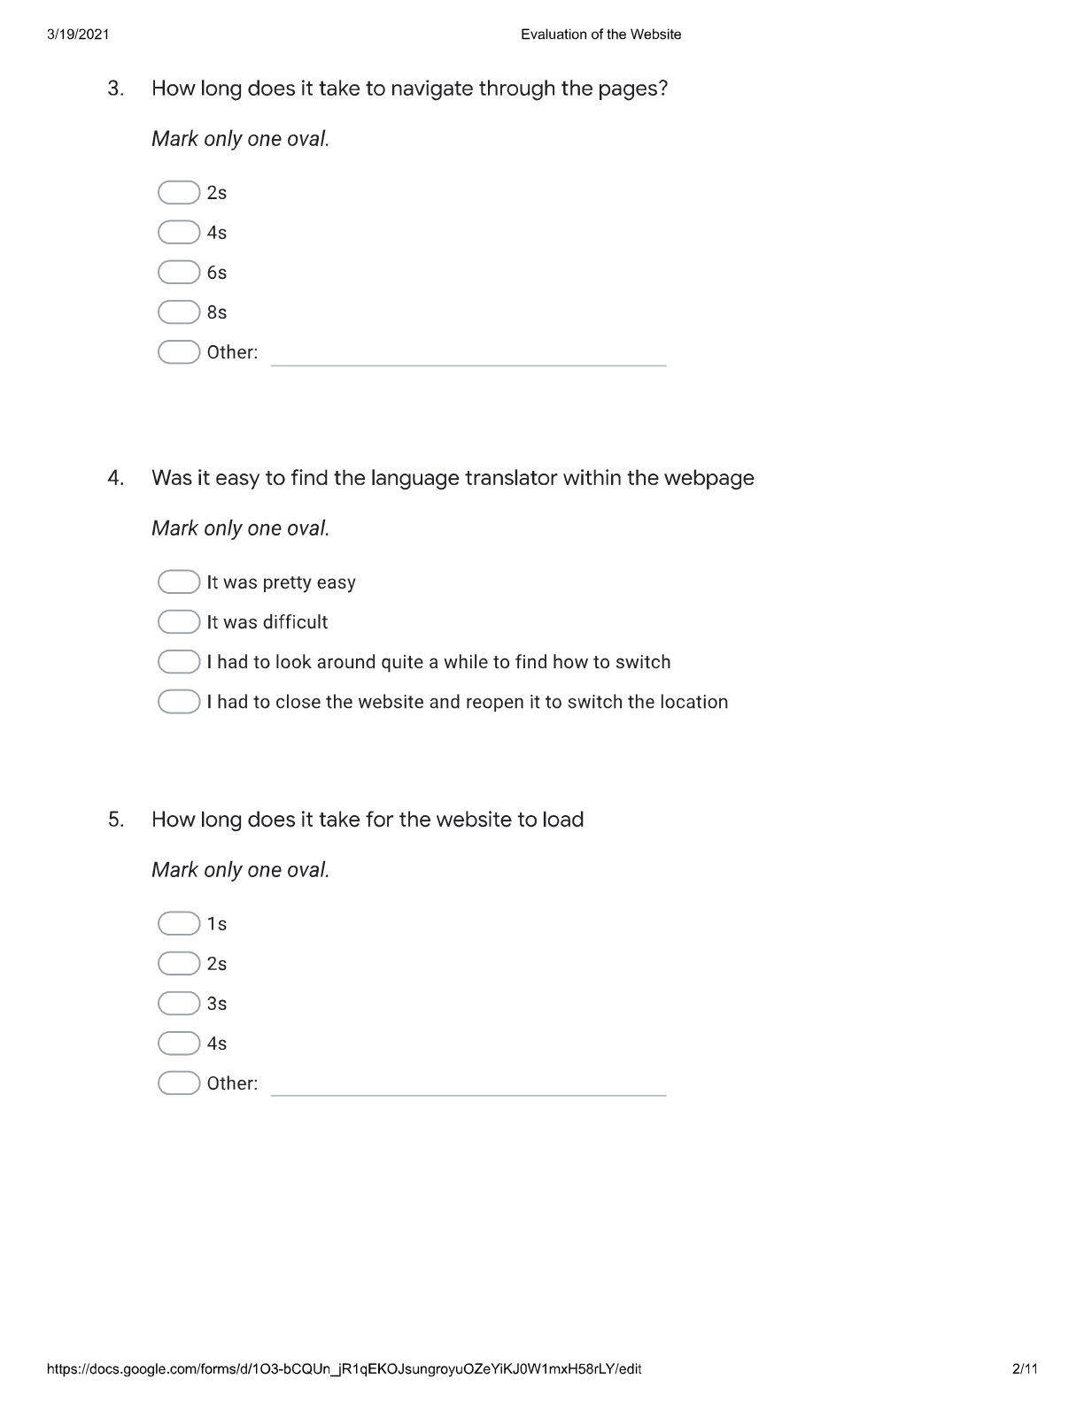

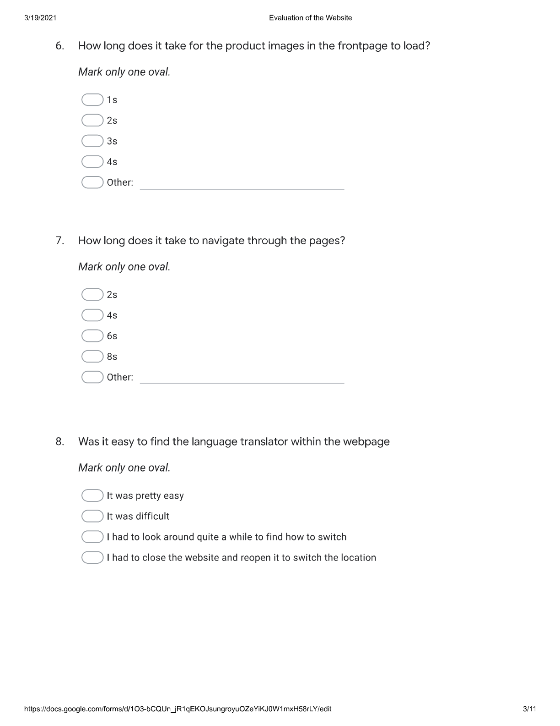

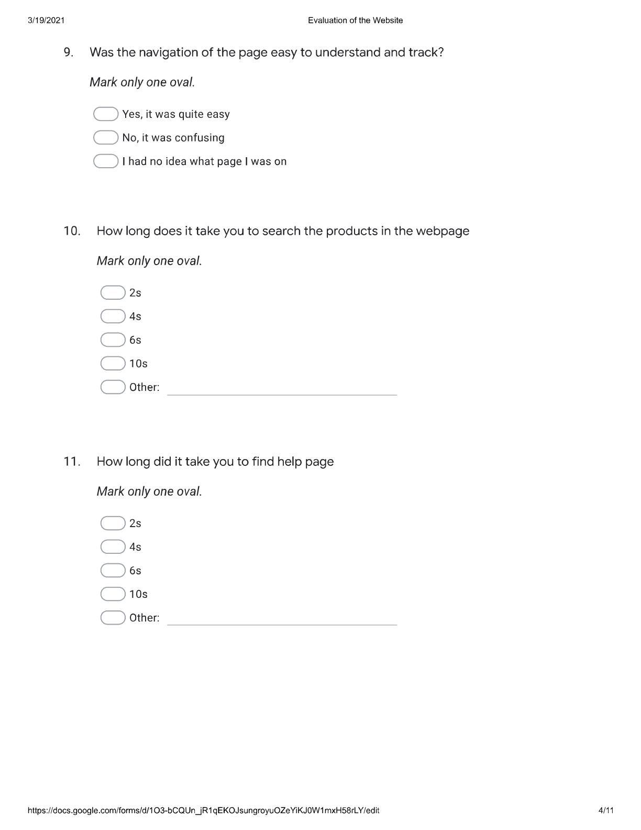

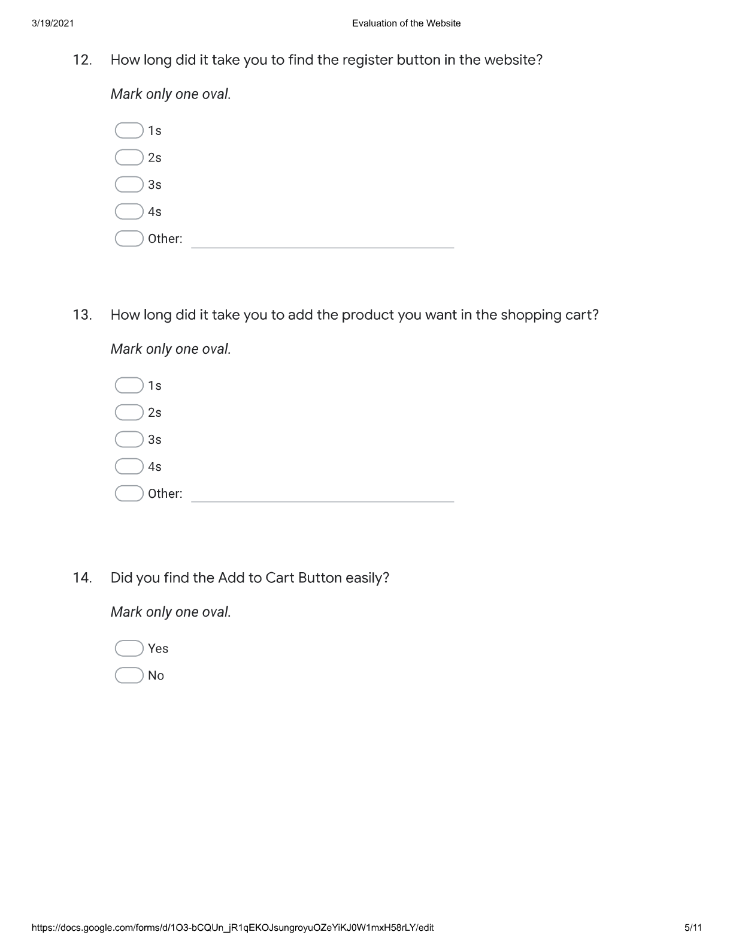

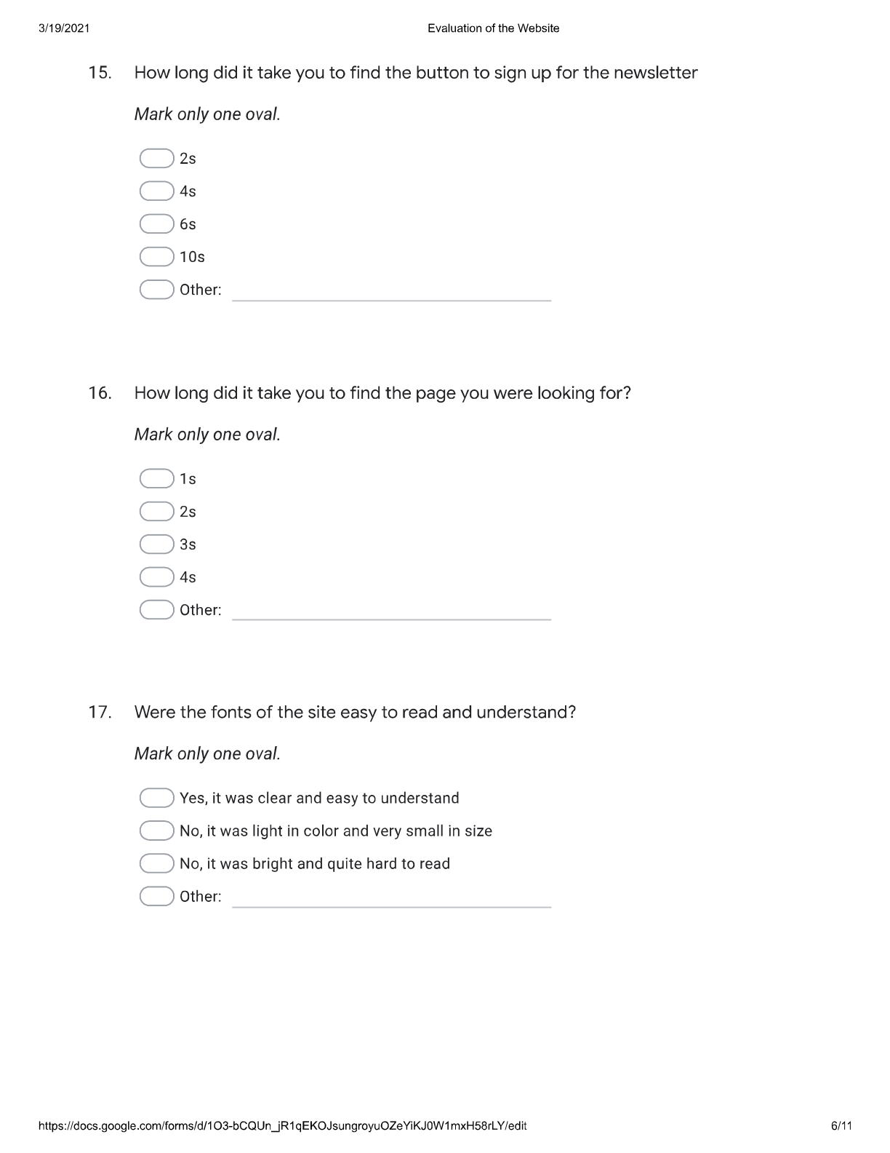

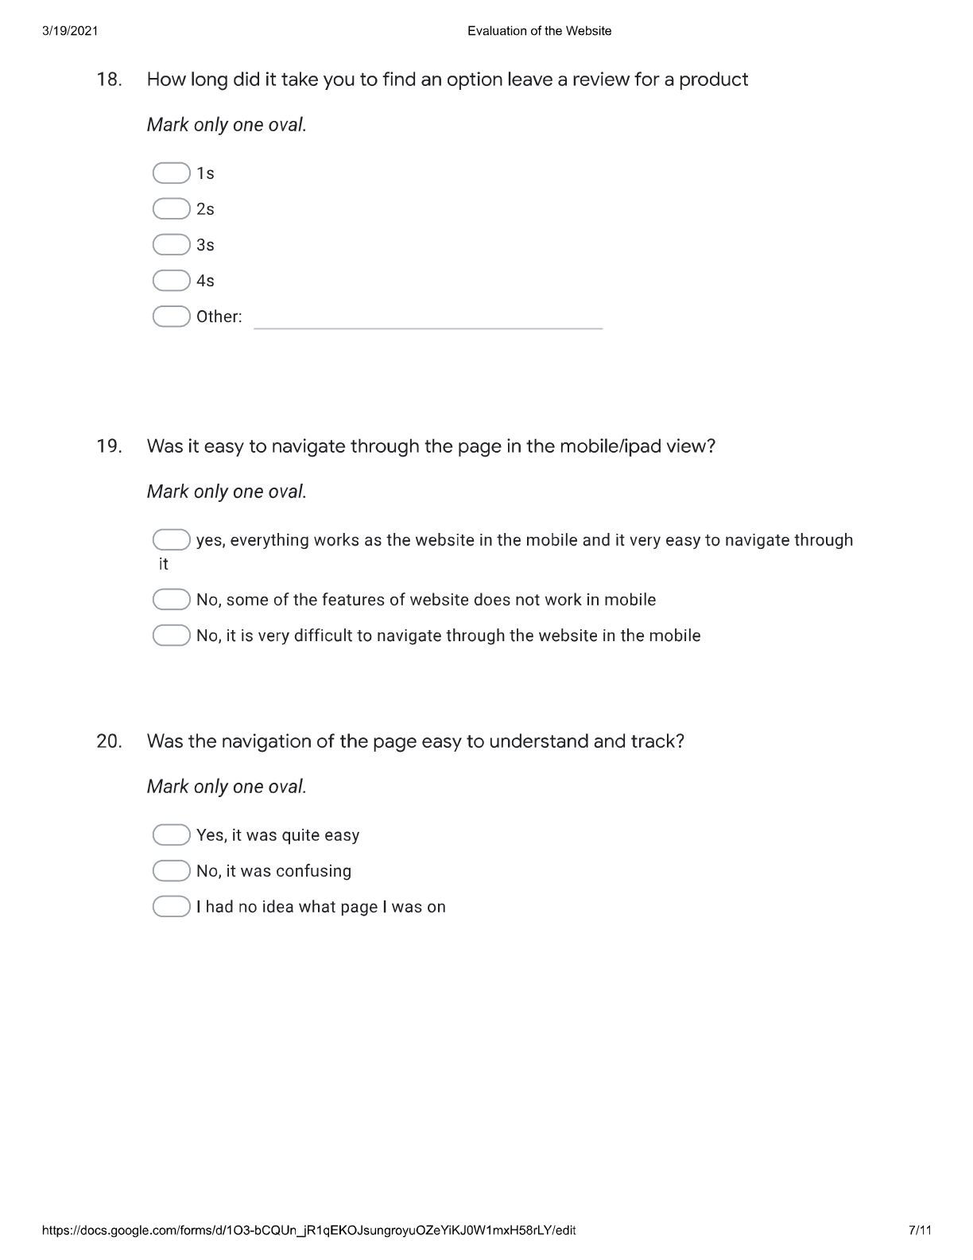

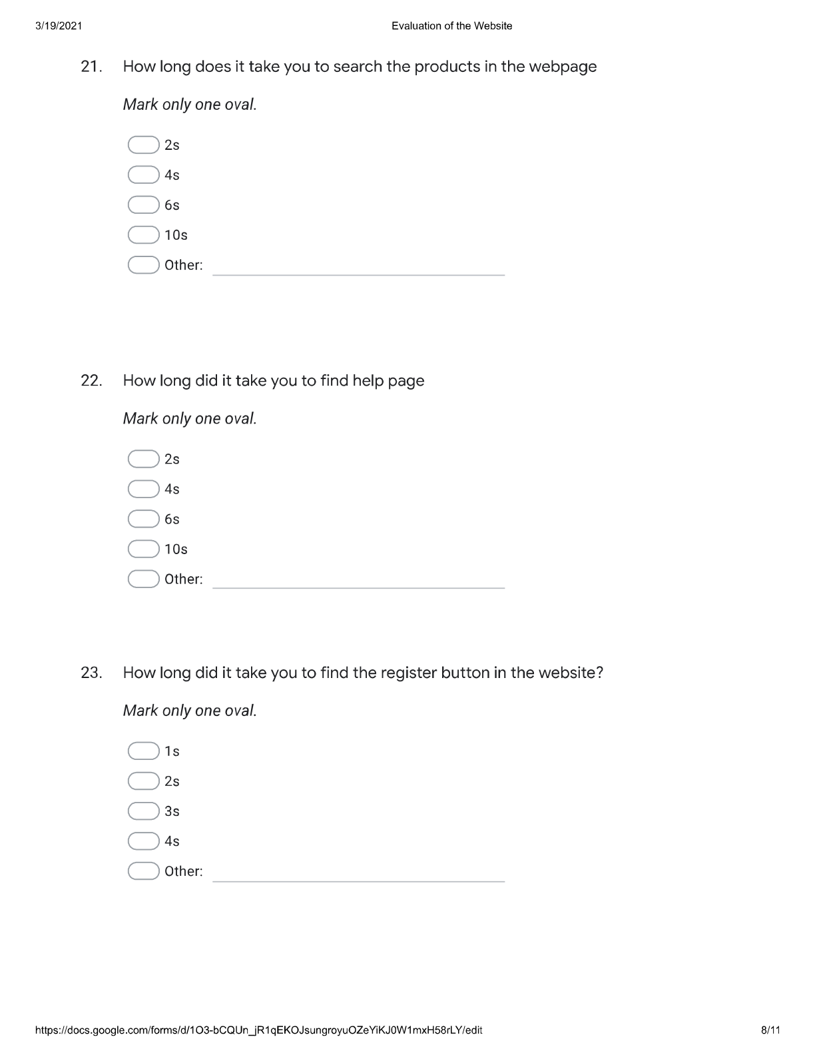

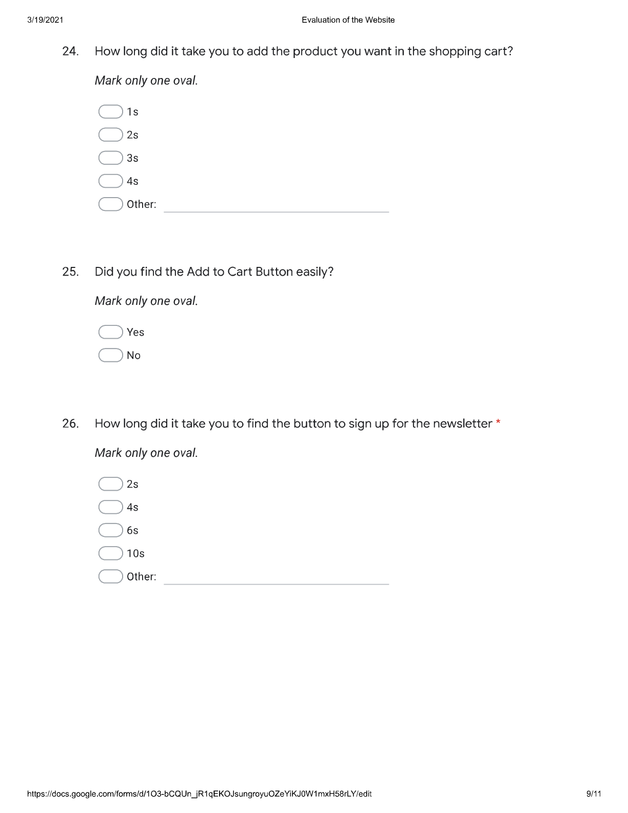

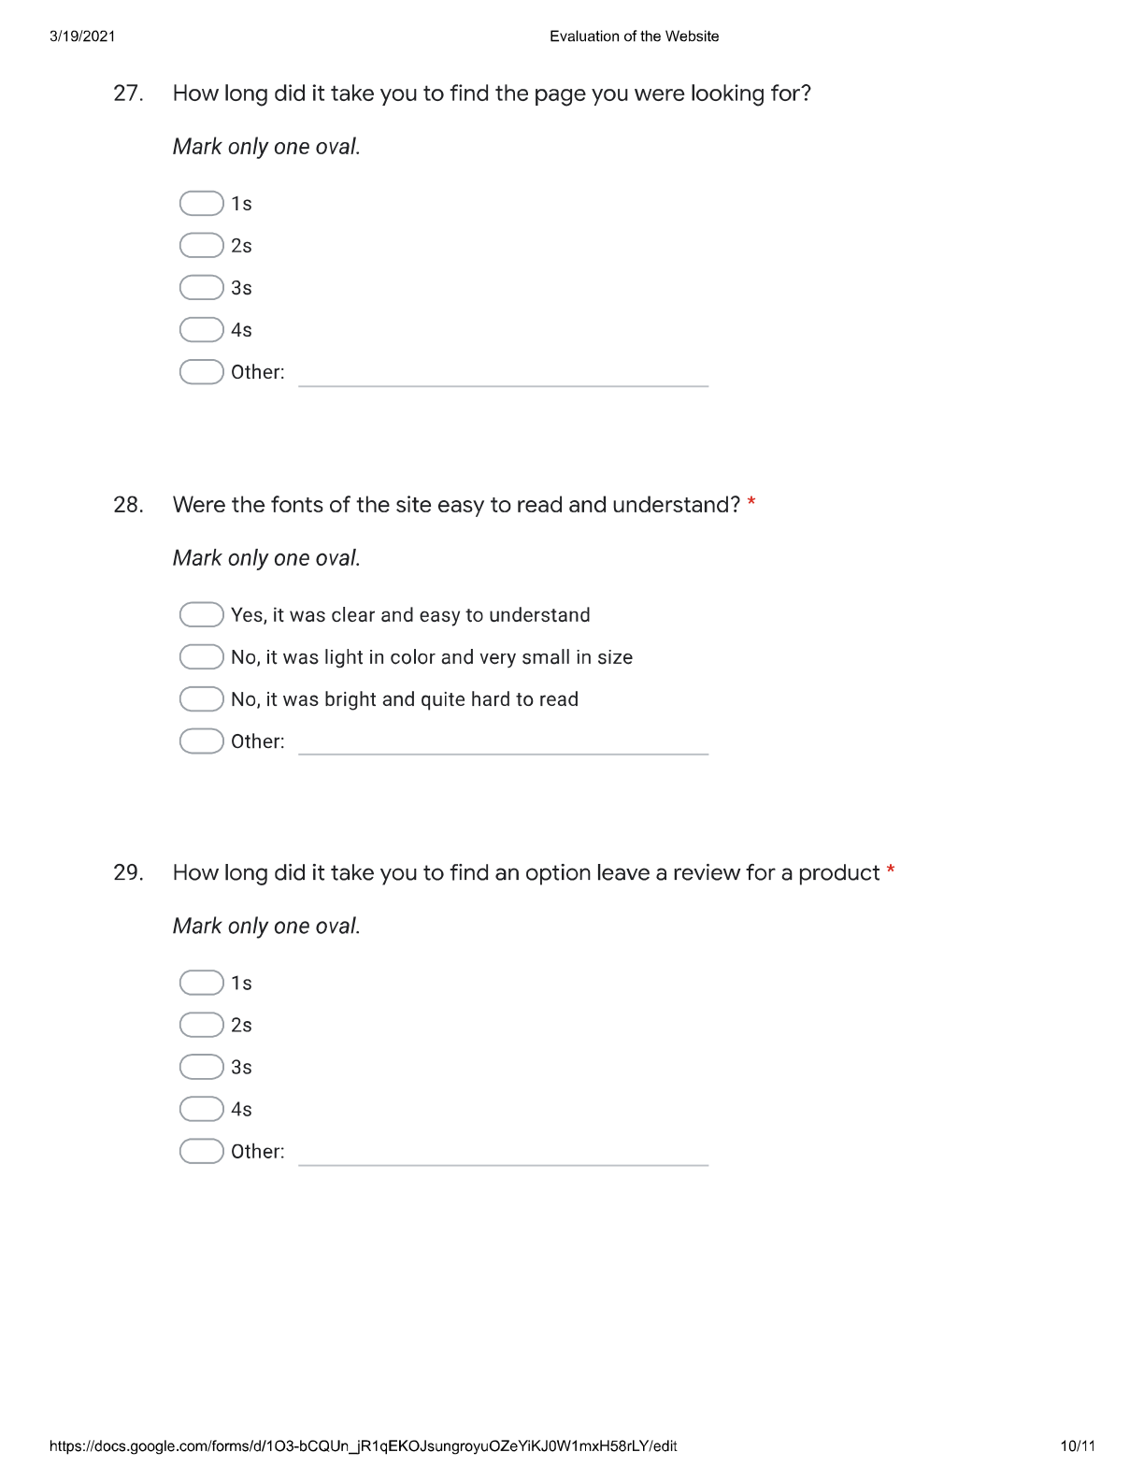

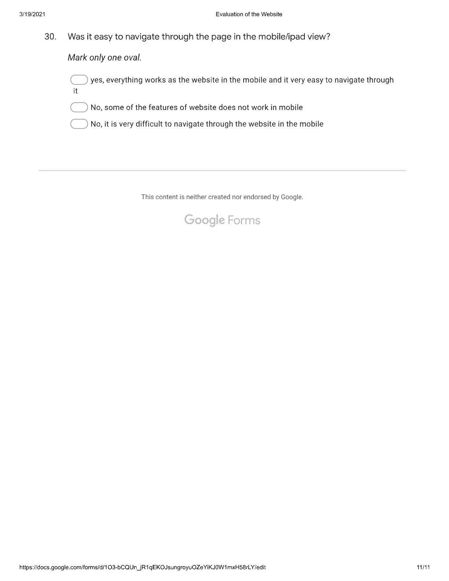

## Lists of general HCI principles

* Ben Shneiderman’s (2010) “Eight golden rules of interface design” and
* Jakob Nielson’s (1994) “Ten Usability Heuristics for User Interface Design”